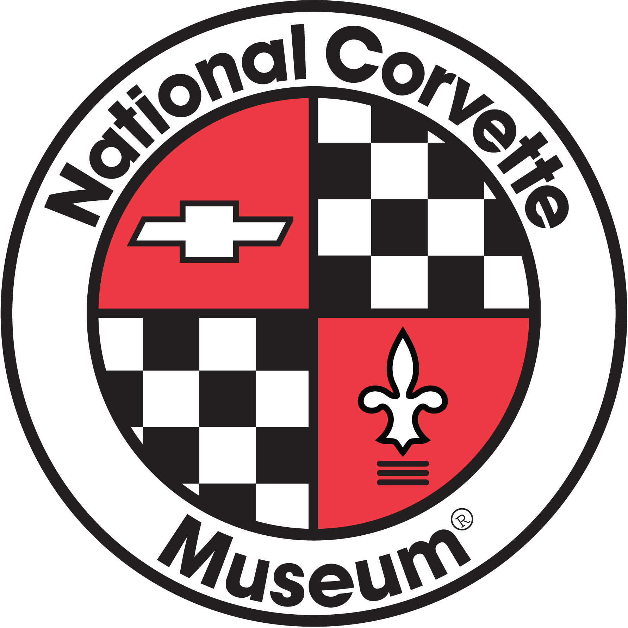
NCM HPDE Student Evaluation

Section 1
• Student Name_____________________________________ | • Instructor’s Name______________________________
• Car Make & Model _________________________________ | • Run Group___________________________________
• Event Location____________________________________ | • Event Date___________________________________

Section 2 Please provide a numerical level with comments to support. 1 = Novice - 5 = Advanced
Student Ratings | 1 – 5 |  |  | 1 – 5
• Uses Proper Hand Signals  ________________________________________ | _____ |  | • Demonstrates A Positive Attitude  ________________________________________ | _____
• Demonstrates Situational Awareness  ________________________________________ | _____ |  | • Uses Proper Driving Position  ________________________________________ | _____
• Uses Proper Line & Full Track Width Use  ________________________________________ | _____ |  | • Identifies And Recovers From Mistakes  ________________________________________ | _____
• Demonstrates Visual Skills  ________________________________________ | _____ |  | • Demonstrates Proper Throttle Control  ________________________________________ | _____
• Uses Smooth Inputs  ________________________________________ | _____ |  | • Uses Proper Heel And Toe Technique  ________________________________________ | _____
• Demonstrates Braking Skills  ________________________________________ | _____ |  | • Keeps Pace With Group  ________________________________________ | _____
• Demonstrates Passing & Off Line Skills  ________________________________________ | _____ |  | • Uses Proper Pit In & Pit Out Procedures  ________________________________________ | _____
• Shows Flag & Safety Protocol Knowledge  ________________________________________ | _____ |  | • Overall Impression  ________________________________________ | _____

Section 3
Solo Approved? ________________ Suggested Run Group?_________________

Section 4
3 goals for student to work on at the next event

NCM HPDE Event Evaluation
To be filled out by Student
Section 1
• Student Name_____________________________________ | • Instructor’s Name______________________________
• Car Make & Model _________________________________ | • Student Run Group_____________________________
• Event Location____________________________________ | • Event Date___________________________________

Section 2 Please provide a numerical ranking with comments to support. 1 = Poor – 5 = Excellent
Instructor Ratings | 1 – 5 |  |  | 1 – 5
• Demonstrated A Calm Demeanor  _______________________________________ | _____ |  | • Demonstrated Vehicle Dynamics Knowledge  ________________________________________ | _____
• Was the Instructor always on time  _______________________________________ | _____ |  | • Uses Understandably Terminology  ________________________________________ | _____
• Demonstrated Professionalism  ________________________________________ | _____ |  | • Classroom Was Engaging And Understandable  _________________________________________ | _____
• Demonstrated Track Knowledge  ________________________________________ | _____ |  | • Classroom Was Applicable To Track Instruction  _________________________________________ | _____
• Encouraged Feedback/Discussion  ________________________________________ | _____ |  | • Overall Impression  ________________________________________ | _____

Section 3
Did Instructor Offer A Ride | Y / N |  | Communicator/Headset Provided | Y / N

Section 4
What could we do to make your NCM HPDE experience better?

